DNS – Domain Name System
Domain Name System or DNS which translates the human-friendly hostnames into the machine IP addresses
- www.google.com to 172.217.18.36
- DNS is the BACKBONE of the Internet
- DNS uses hierarchical naming structure:
.com
example.com
www.example.com
api.example.com
Domain Registrar: is a company or entity that allows you to register and manage internet domain names
- DNS Terminologies
- Domain Regsitrar: Amazon Route 53, GoDaddy, CloudFlare,…
- DNS records: A, AAAA, CNAME, NS,…
- Zone File: contains DNS records
- Name server: resolves DNS queries ( Authoritative or Non-Authoritative)
- Top Level Domain – TLD: .com, .us, .in, .gov, .edu,….
- Second Level Domain – SLD: amazon.com, google.com,….
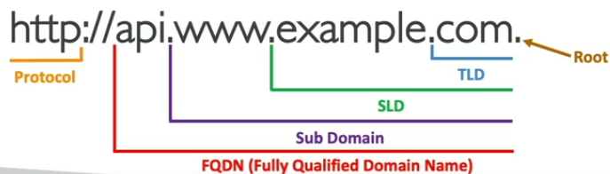

How DNS works?
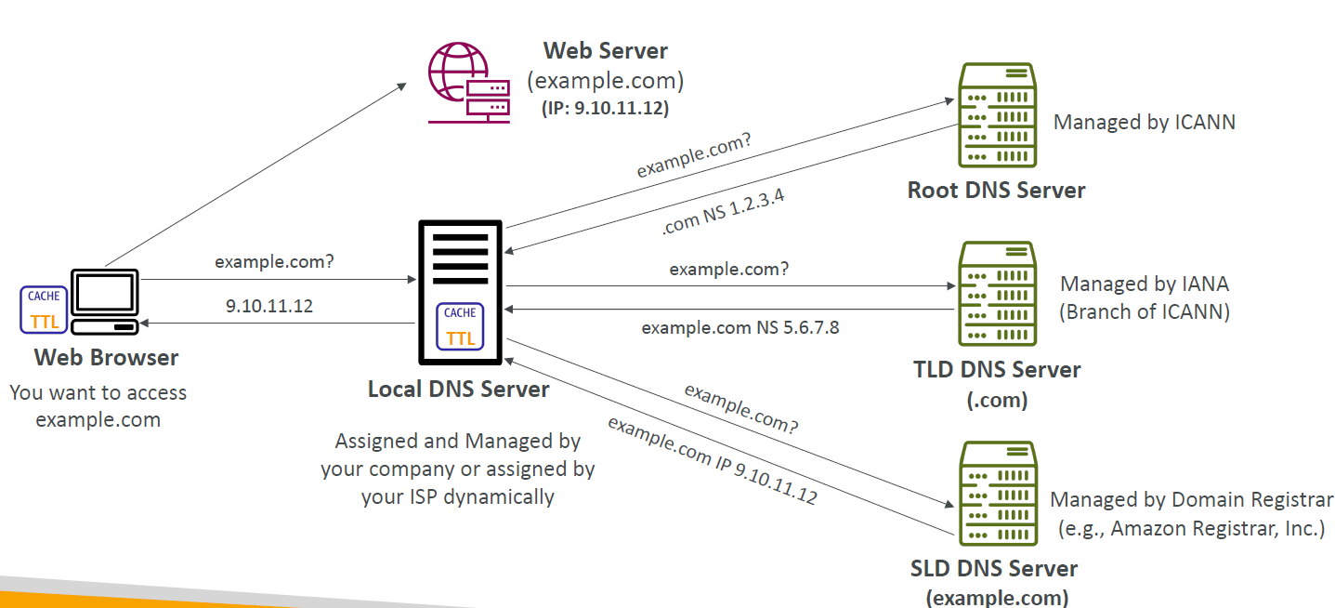
Explain:
Web: example.com; public IP: 9.10.11.12
- Web browser ask Local DNS what is example.com if Local DNS never seen before:
- Local DNS ask Root DNS server what is example.com Root DNS also never seen but it recognize the .com part NS is 1.2.3.4 and return the response to Local DNS
- Local DNS ask Top Level Domain (TLD) ask what what is example.com TLS DNS doesn’t know it but it know a server example.com with NS 5.6.7.8 and response the answer to Local DNS
- Local DNS asks Second Level Domain(SLD) DNS what is example.com SLD know the answer and response the public IP of example.com is 9.10.11.12
- Local DNS will send the answer aka public IP back to Web Browser
- Finally Web Browser will access to example.com through it public IP 9.10.11.12

Amazon route 53
- A highly available, scalable, full managed and Authoritative DNS (You have full control over this DNS and you can update DNS records)
- Route 53 is also a Domain Registrar
- Ability to check the health of your resources
- The only AWS service provides 100% availability SLA

Route 53 – Records
• How you want to route traffic for a domain
• Each record contains:
• Domain/subdomain Name – e.g., example.com
• Record Type – e.g., A or AAAA
• Value – e.g., 12.34.56.78
• Routing Policy – how Route 53 responds to queries
• TTL – amount of time the record cached at DNS Resolvers
• Route 53 supports the following DNS record types:
• (must know) A / AAAA / CNAME / NS
• (advanced) CAA / DS / MX / NAPTR / PTR / SOA / TXT / SPF / SRV
Route 53 – Record types
- A – maps a hostname to IPv4
- AAAA – maps a hostname to IPv6
- CNAME – maps a hostname to another hostname:
  - The target is a domain name and must have an A or AAAA record (IPv4 or IPv6)
  - Can’t create CNAME record for the top node of DNS namespace(Zone Apex)
  - Ex: you can’t create cname for example.com but can create cname for www.example.com or using alias can work too
- NS – Name Servers for the hosted zone: control how traffic is routed for a domain

Route 53 – Hosted Zones
- A container for records that define how to route traffic to a domain and its subdomains
- Public Hosted Zones – contains records that specify how to route traffic on the Internet (or public domain names) application1.mypublicdomain.com
- Private Hosted Zones – contain records that specify how you route traffic within 1 or more VPCs (private domain names)
- You pay 0.5$ per month per hosted zone

Route 53 – Public vs Private Hosted Zones
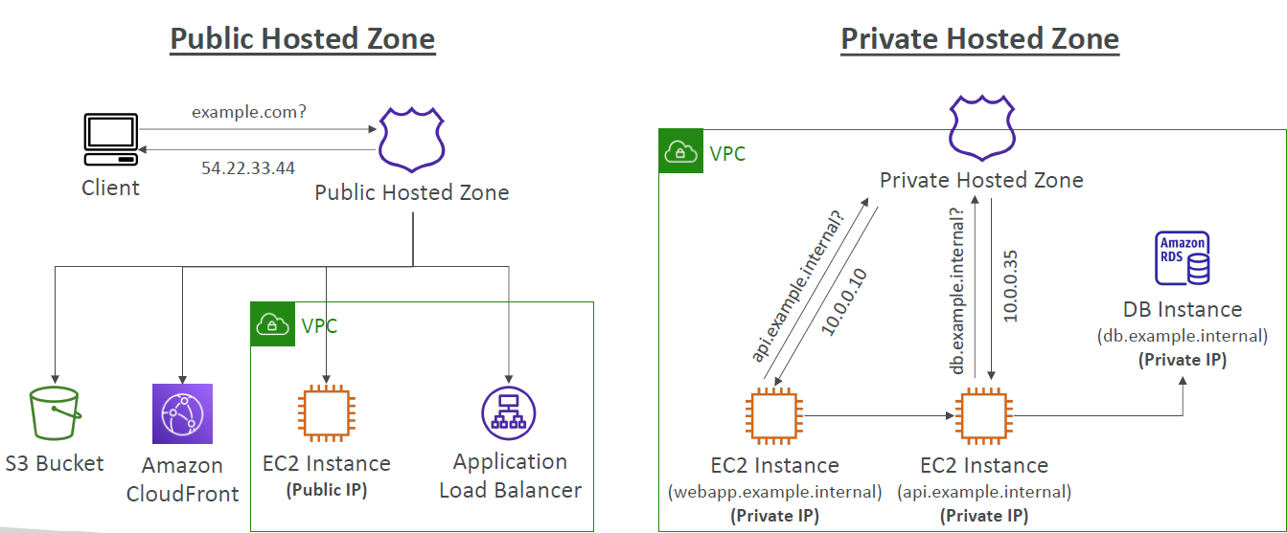

Route 53 – Hands on
Course: Ultimate AWS Certified Solutions Architect Associate SAA-C03 | Udemy
To get started: Register domains – This will cost money
Input domain name. Ex: domain_name.com and choose duration(price) and Enable/disable Auto-renew
Input Contact information and Privacy Connection
Finally Submit to register domain and pay money for the domain
Test domain name: https://www.evbthereunion.com
Now you can go to Hosted Zones in Route 53 to manage your domains or Create a new hosted zones by adding the domains you already have in it for validation
Example:
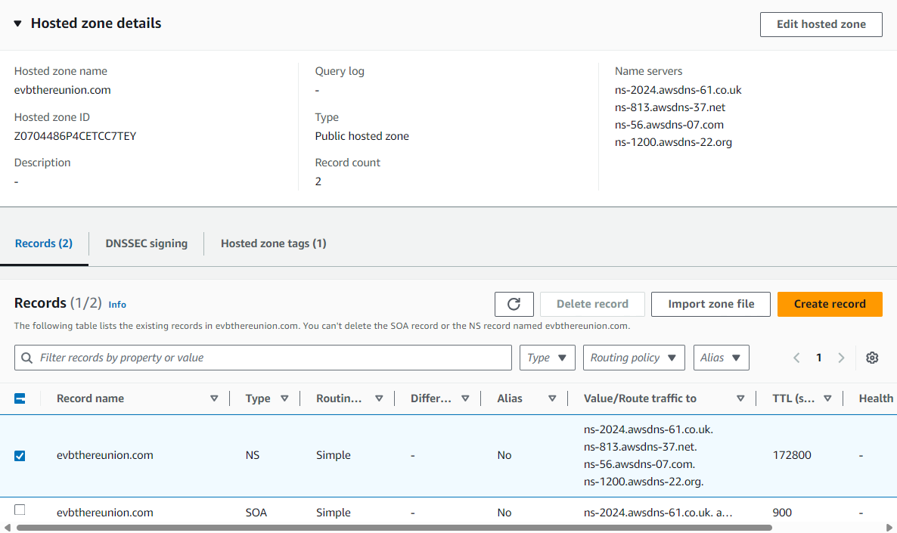
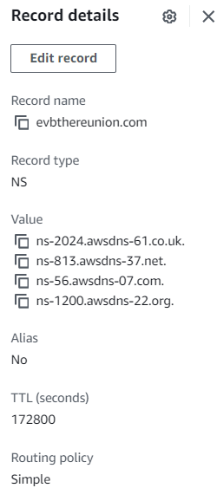

Route 53 - Records
Select the Hosted Zone then press Create Record
Input record name
Input record type. Ex: A – route traffic to IPv4
Value. Ex: 11.22.33.44
TLS: 300s, Routing policy Simple routing
Result
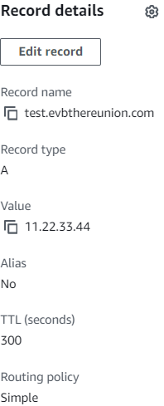

Route 53 – EC2
Step1 : Create three instances in 3 different regions like Singapore, US Virginia, EU Germany
Step 2: Create ALB for instance 1 Singapore
Result: when access to Public IP of that EC2 Ex: 18.142.49.159
Response: Hello world from ip-172-31-19-178.ap-southeast-1.compute.internal in AZ ap-southeast-1b
IP: 52.29.107.64
Response: Hello world from ip-172-31-38-100.eu-central-1.compute.internal in AZ eu-central-1b
IP: 35.175.185.161
Response: Hello world from ip-172-31-17-2.ec2.internal in AZ us-east-1d

Route 53 - Records TTL( Time To Live)
TTL purpose to return a A record IPv4 response with The Time Live of for example 300s to avoid Client constantly send request to DNS in short amount of time until 300s later with TTL has expired. The reason to reduce traffic on Route 53
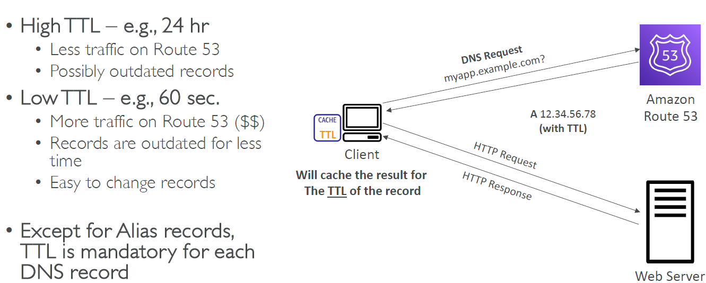
Demo on create Record with Value is the IP of 1 of the EC2 instances you created previously and with TTL 120s

CNAME vs Alias
- Both AWS Resources(Load Balancer, CloudFront,..) expose and aws hostname
- CNAME:
  - Points a hostname to another hostname (app.mydomain.com => abcxyz.com)
  - ONLY FOR NON ROOT DOMAIN
- Alias:
  - Points a hostname to AWS resources(app.mydomain.com => abcxyz.aws.com)
  - Free of charge
  - Native health check

Alias Records
- Maps a hostname to an AWS resource
- An extension to DNS functionality
- Automatically recognizes changes in resource’s IP addresses
- Unlike CNAME, it can be used for top node of a DNS name space(Zone Apex). Ex: example.com
- Alias Record is always type A/AAAA (IPv4/IPv6) for AWS resources
- You can’t set TTL for Alias records

Alias Records Targets
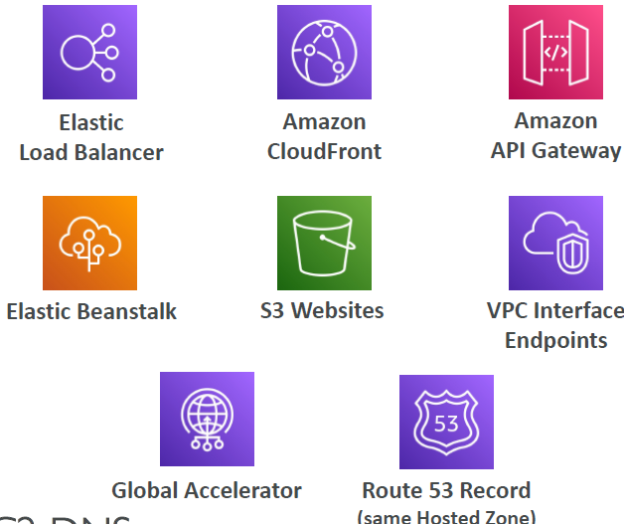
- Elastic Load Balancer
- CloudFront distributions
- API Gateway
- Elastic Beanstalk environment
- S3 websites
- VPC Interface Endpoints
- Global Accelerator
- Route 53 record in the same hosted zone
- You cannot set ALIAS record for EC2 DNS name.

Routing Policies
Define how Route 53 responds to DNS queries
DNS does not route any traffic, it only RESPONDS TO DNS QUERIES
It’s not the same Routing as Load Balancing routing which routes the traffic
Route 53 supports Routing Policies:
- Simple
- Weighted
- Failover
- Latency used
- Geolocation
- Multi-Value Answer
- Geoproximity

